Post-Graduation Activities Report

Quick Facts
• • •
Response rate for the survey of May 2017 Luther College graduates was 95.8%
Approximately 98% of May 2017 graduates reported being employed, continuing their education, or not intentionally seeking employment within 8 months after graduating.
88.7% of Luther College graduates in May 2017 reported that their post-grad activity was related to their career goals.

Luther College Class of 2017 – The Career Center

Introduction
The data collection process for this report took place from May 2017 to December 2017. For those students who had solidified their plans prior to graduation, the Career Center received their information in May 2017. For students who were still unsure about their plans, data were gathered through a survey sent between May 2017 through November 2017, followed by telephone calls, emails and surveying social media in December 2017. Through these efforts, Luther College had a survey totaling response rate of 95.8%. This rate includes sources of data from reliable and verifiable information from faculty, employers and social media.

Post-Graduation Activities
Post-college activities of the 2017 graduates were divided into eight categories: employed, which includes full-time and part-time employment (72.1%); accepted/enrolled in graduate school or another program of continuing education (15.7%); participating in a volunteer or service program (5.9%); planning to continue education but not yet enrolled (1.7%); still seeking employment (2.6%), serving in the U.S. military (0%) and participating in none of these activities (2.0%). A few categories deserve further explanation. Students in a “program of continuing education” were enrolled in an undergraduate program to further their education, for example, to obtain a teaching license, or were participating in some other activity to gain the necessary credentials to enter their field of choice. The “employed” category includes students who were employed either full-time (90%) or part-time (10%), both of which include respective internships and fellowships. Per the U.S. Department of Labor, full-time employment is defined as working a minimum of 30 hours per week. 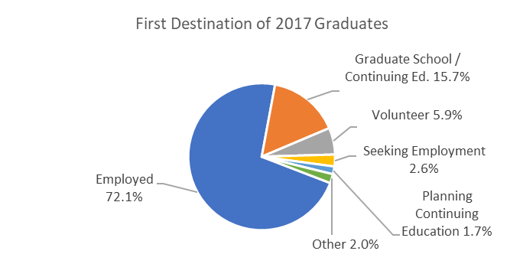
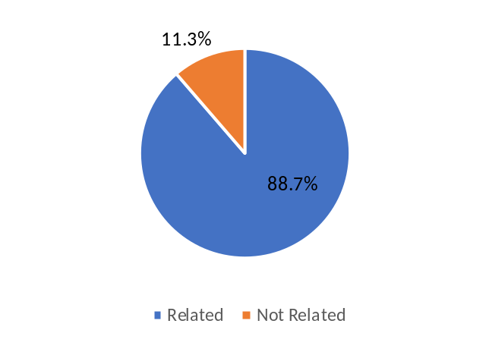

Career Goals: Are Graduates Doing What They Want to Do?

When asked if their employment was related to their career goals, 88.7% of employed May 2017 graduate who responded to this question replied affirmatively. This statistic includes those in graduate school and those continuing their education.

Graduates Pursuing Further Education
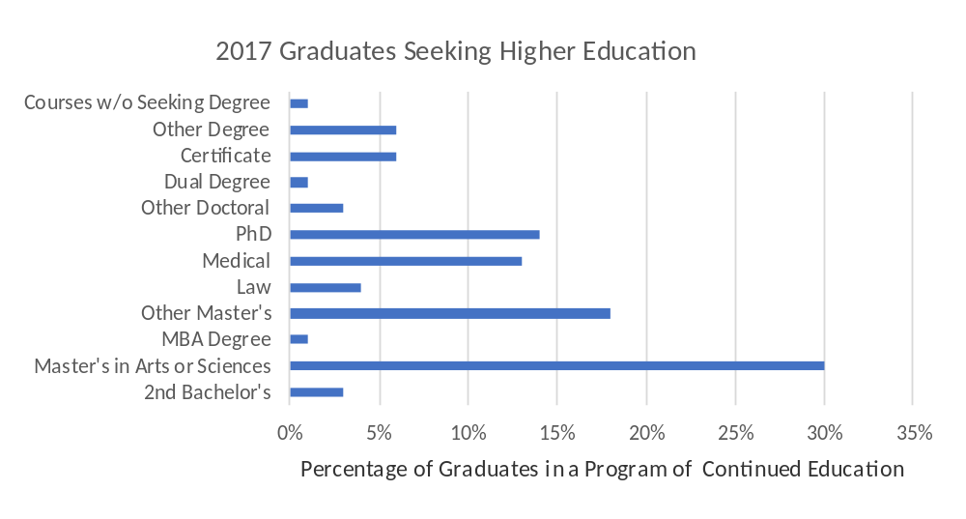
Among the 2017 graduates who elected to attend graduate or professional school (with one non-respondent), the largest percentage (30%) reported pursuing a master’s degree in arts or sciences. Other advanced degrees being sought include medical (13%), other master’s degree (e.g., MAT, MFA, MPA, etc.) (18%), PhD (14%), law (4%) and other degrees (6%). Minnesota and Iowa were top destination states for students pursuing graduate or professional school studies, with 37% and 20% respectively. Other states included Colorado followed with 10%, Illinois with 6% and Wisconsin attracted 4% of our students pursuing graduate study. The remaining 23% of surveyed students elected to continue their graduate studies in one of 12 other states, as well as 2 countries abroad.

Top Graduate School Destinations

University of Minnesota 9
A.T. Still University 4
University of Iowa 4
Iowa State University 3
Des Moines University 2
St. Ambrose University 2
St. Catherine University 2

Top Graduate School Destinations

Approximately 41% of the respondents that were attending graduate school are located at one of the institutions listed in the table at the right. Four also reported studying overseas, with three attending institutions in the United Kingdom and one in Norway.

Statuses of Full-time and Part-time Employment

Employed freelance 3
Working as an entrepreneur 7
Internship or fellowship 24
Temporary/contract work 29
Hired by an employer 246
Total respondents: 309

Employment Activities
When asked about the primary status of students’ full-time and part-time employment, the largest employment activity for the class of 2017 was reported as being hired by an employer or organization, with 80% of respondents answering that choice. Due to the nature of this question, other full-time and part-time employment activities fall under the other categories listed on the right. Participating in temporary/contract work (9%) and an internship or fellowship (8%) were the top three statuses for respondents. The table to the right provides all five options answered by 2017 graduates.

Geographic Location of Employment
For those students who decided to join the workforce, the location of employment spans the nation. Minnesota was the top destination for May 2017 graduates, attracting approximately 44% of the class. Iowa earned second place, with 24%. Wisconsin is home to 11% of graduates, Illinois 5%, and Colorado 2%. The remaining 14% of employed graduates found employment outside of this five-state region.

Selected Employers of 2017 Graduates –

Number of Hires
Business: |  | Social Sciences/Education:
Deloitte--------------------------------------------------------- | 3 | Iowa Schools--------------------------------------------- | 13
EY ------------------------------------------------------------ | 2 | Minnesota Schools-------------------------------------- | 17
Deco Products------------------------------------------------ | 2 | Wisconsin Schools-------------------------------------- | 4
 |  | Schools in Other States------------------------------- | 8
 |  | Luther College ----------------------------------------- | 6
Sciences: |  | Technology:
Mayo Clinic---------------------------------------------------- | 13 | Amazon---------------------------------------------------- | 2
University of Iowa Hospitals & Clinics------------------ | 2 | Epicor Software------------------------------------------ | 1
Mercy Medical Center-------------------------------------- | 3 | Fareway---------------------------------------------------- | 1
Winneshiek Medical Center------------------------------- | 2 | IBM---------------------------------------------------------- | 1
Abbot Northwestern Hospital------------------------------ | 1 | Preventice------------------------------------------------- | 1

Selected Employers
Students pursued employment across a wide variety of regional, national, and international organizations. The table highlights a few of the employers arranged by broad industry groupings, followed by the number of Luther graduates they hired. The list is not exhaustive, but it does provide a snapshot of where Luther graduates are contributing.

Volunteer Service
About 5.9 percent of the class of 2017 pursued volunteer service as their initial career path after leaving Luther. To be classified in this category, students must have committed to at least 10 months of consecutive service. Eleven Luther graduates chose to volunteer with Americorps and affiliated programs such as Americorps VISTA and College Possible. Five students are volunteering with the Evangelical Lutheran Church of America (ELCA) or the ELCA Young Adults in Global Mission (YAGM). Two graduates chose to serve with the Lutheran Volunteer Corps and two graduates chose to serve with the Peace Corps. Other graduates chose a variety of regional nonprofits across the country and around the world.

Migration of Iowa/Non-Iowa Residents
STATE OF RESIDENCY OF STUDENTS | LOCATION OF EMPLOYMENT
STATE OF RESIDENCY OF STUDENTS | Iowa | Minnesota | Wisconsin | Another State/Country
Iowa | 50% | 24% | 6% | 20%
Minnesota | 11% | 82% | 1% | 6%
Wisconsin | 10% | 32% | 46% | 12%
Other | 21% | 19% | 9% | 51%
For several years Iowa
legislators have focused on the migration of college-educated individuals. Graduates who pursue employment or graduate school in and out of Iowa are commonly referred to as “brain gain/brain drain”. The charts above and below reflect the migration of Luther graduates for employment and graduate school, categorized by their respective home state, or state of residency. For example, of the Iowa residents who are employed, 50% were working in the state of Iowa while 50% accepted employment in another state. Of the Iowa residents enrolled in graduate school, 48% are attending an Iowa institution while 52% enrolled in an institution in another state. The charts also include migration data for Luther graduates from both Minnesota and Wisconsin.

Graduate School Migration
RESIDENCY OF STUDENTS | LOCATION OF GRADUATE SCHOOL
RESIDENCY OF STUDENTS | Iowa | Minnesota | Wisconsin | Another State/Country
Iowa | 48% | 9% | 0% | 43%
Minnesota | 4% | 63% | 4% | 29%
Wisconsin | 0% | 33% | 67% | 0%
Other | 13.3% | 13.3% | 0% | 73.3%

Applied Learning
According to Luther College records, 153 students of the Class of 2017 graduates completed a for-credit internship at some point during their studies at Luther. Responses to the Office of Assessment and Institutional Research survey show that at least 23 graduate participated in a non-credit internship. At least 96 graduates participated in a practicum or clinical as part of their work in Luther’s athletic training, education, nursing, or social work program.

CONCLUSION
The Class of 2017 graduated as the U.S. economy’s unemployment rate has gradually improved from a 4.9% rate January 2016 to 4.8% as of January 2017 according to the Bureau of Labor Statistics. Based on eight years of survey data, Luther graduates have consistently found employment, entered graduate school, and sought volunteer opportunities at the same rate, regardless of economic conditions.

ADDENDUM: Post-Graduation Status According to Major
The table on the last page summarizes the data that contributed to this report. The table is organized according to majors. Students who majored in more than one area are represented in each of the major they obtained; therefore, the distribution of majors listed in the table does not correspond to the number of 2017 graduates. Raw numbers are in boldface and outside of the parentheses in each category, when available.

For more information about the Luther College Career Center, please visit http://career.luther.edu or call 563-387-1025.

 |  | POST-GRADUATION STATUS ACCORDING TO MAJOR
Major |  |  | Distribution of Majors | # Responding | % Responding | Employed Full-time | Employed Part-time | Accepted /enrolled in Graduate School OR Other Continuing Education | Volunteer/Service Program | Serving in U.S. Military | Seeking Employment | Planning to continue education/not yet accepted or enrolled | None of these
Accounting |  |  | 17 | 16 | 94% | 15 (94%) | -- | -- | 1 (6%) | -- | -- | -- | --
Africana Studies |  |  | 1 | 1 | 100% | -- | -- | 1 (100%) | -- | -- | -- | -- | --
Anthropology |  |  | 7 | 7 | 100% | 5 (71%) | -- | 2 (29%) | -- | -- | -- | -- | -
Art |  |  | 13 | 11 | 85% | 6 (55%) | 1 (9%) | 1 (9%) | 2 (18%) | -- | 1 (9%) | -- | --
Athletic Training |  |  | 5 | 5 | 100% | 0 | 1 (20%) | 4 (80%) | -- | -- | -- | -- | --
Biblical Languages |  |  | 0 | 0 | - | ---- | -- | -- | -- | -- | -- | -- | --
Biology |  |  | 57 | 54 | 95% | 22 (41%) | 3 (5%) | 19 (35%) | 7 (13%) | -- | -- | 2 (4%) | 1 (2%)
Chemistry |  |  | 16 | 16 | 100% | 10 (63%) | -- | 4 (25%) | 1 (6%) | -- | 1 (6%) | -- | --
Classics |  |  | 6 | 6 | 100% | 3 (50%) | -- | 3 (50%) | -- | ------ | -- | -- | --
Communication Studies |  |  | 16 | 16 | 100% | 15 (94%) | -- | 1 (6%) | -- | -- | -- | -- | --
Computer Science |  |  | 25 | 22 | 88% | 17 (77%) | 1(5%) | 2 (9%) | -- | -- | -- | -- | 2 (9%)
Dance |  |  | 3 | 3 | 100% | 3 (100%) | -- | -- | -- | -- | -- | -- | --
Economics |  |  | 15 | 15 | 100% | 14 (93%) | -- | -- | -- | -- | 1 (7%) | -- | --
Elementary Education |  |  | 23 | 23 | 100% | 19 (83%) | 2 (9%) | 1 (4%) | -- | -- | -- | -- | 1 (4%)
English |  |  | 26 | 26 | 100% | 12 (46%) | 2 (8%) | 6 (23%) | 4 (15%) | -- | -- | -- | 2 (8%)
Environmental Studies |  |  | 22 | 21 | 95% | 14 (67%) | -- | -- | 3 (14%) | -- | 2 (9%) | 1 (5%) | 1 (5%)
French |  |  | 7 | 7 | 100% | 4 (57%) | 2 (29%) | -- | 1 (14%) | -- | -- | -- | --
German |  |  | 7 | 7 | 100% | 5 (72%) | 1(14%) | -- | -- | -- | 1 (14%) | -- | --
Health/Health Education |  |  | 10 | 10 | 100% | 6 (60%) | 2 (20%) | 1 (10%) | -- | -- | -- | 1 (10%) | --
History |  |  | 10 | 10 | 100% | 4 (40%) | -- | 4 (40%) | 1 (10%) | -- | -- | 1 (10%) | --
INDIV-Elementary Education: Non-Teaching |  |  | 1 | 1 | 100% | -- | 1 (100%) | -- | -- | -- | -- | -- | --
Intermedia Arts |  |  | 1 | 1 | 100% | -- | 1 (100%) | -- | -- | -- | -- | -- | --
International Studies |  |  | 14 | 14 | 100% | 11 (79%) | -- | 1 (7%) | 1 (7%) | -- | 1(7%) | -- | --
Management |  |  | 48 | 46 | 96% | 40 (87%) | 1 (2%) | -- | 1 (2%) | -- | 3 (7%) | -- | 1 (2%)
Mathematics/Math Statistics |  |  | 18 | 16 | 89% | 8 (50%) | 1 (6%) | 6 (38%) | 1 (6%) | -- | -- | -- | --
Music |  |  | 36 | 33 | 92% | 20 (61%) | 2 (6%) | 9 (27%) | -- | -- | -- | 1 (3%) | 1 (3%)
Nordic Studies |  |  | 4 | 4 | 100% | 3 (75%) | -- | -- | 1 (25%) | -- | -- | -- | --
Nursing |  |  | 23 | 22 | 96% | 22 (100%) | -- | -- | -- | -- | -- | -- | --
Philosophy |  |  | 4 | 4 | 100% | 2 (50%) | -- | 1 (25%) | 1 (25%) | -- | -- | -- | --
Physical Ed. |  |  | 12 | 12 | 100% | 2 (17%) | 4 (33%) | 5 (42%) | -- | -- | 1 (8%) | -- | --
Physics |  |  | 10 | 10 | 100% | 4 (40%) | 1 (10%) | 3 (30%) | 1 (10%) | -- | 1 (10%) | -- | --
Political Science |  |  | 21 | 20 | 95% | 10 (50%) | 2 (10%) | 4 (20%) | 2 (10%) | -- | 2 (10%) | -- | --
Psychology |  |  | 36 | 36 | 100% | 21 (58%) | 4 (11%) | 5 (14%) | 3 (8%) | -- | 1 (3%) | 2 (6%) | --
Religion |  |  | 11 | 9 | 82% | 6 (67%) | 2 (22%) | -- | 1 (11%) | -- | -- | -- | --
Russian Studies |  |  | 2 | 2 | 100% | 1 (50%) | -- | 1 (50%) | -- | -- | -- | -- | --
Social Work |  |  | 15 | 13 | 87% | 8 (61%) | 1 (8%) | 3 (23%) | -- | -- | -- | 1 (8%) | --
Sociology |  |  | 9 | 9 | 100% | 6 (67%) | 1 (11%) | 1 (11%) | 1 (11%) | -- | -- | -- | --
Spanish |  |  | 16 | 16 | 100% | 9 (56%) | 1 (6%) | 3 (19%) | 2 (13%) | -- | -- | -- | 1 (6%)
Theatre |  |  | 10 | 10 | 100% | 7 (70%) | 3 (30%) | -- | -- | -- | -- | -- | --
Women's & Gender Studies |  |  | 0 | 0 | 0% | -- | -- | -- | -- | -- | -- | -- | --
TOTALS |  |  | 577 | 554 | 96% | 354 | 40 | 91 | 35 | 0 | 15 | 9 | 10
- NOTE: Students with more than one major are counted in each major declared. Information compiled this year was gathered using the HEDS survey system.

